6 March 2025

REFERRAL RESPONSE – ENVIRONMENTAL HEALTH

FILE NO: | Development Applications: 376/2024/1
ADDRESS: | 29-53 Victoria Road BELLEVUE HILL 2023
PROPOSAL: | Demolition of the existing outdoor swimming pool of Scots College and construction of a new swimming pool and associated facilities including pool plant room, spectator seating and storage area.
FROM: | Louie Salvatore
TO: | Mr M D'Alessio

- ISSUES

- Acoustics – Construction & Mechanical Services.

- DOCUMENTION

I refer to the following documents received for this report:

- Acoustic Report: prepared by E-LAB Consulting – Project No. P01282 – Revision 003 – 03 March 2025.

- RESEARCH

The following research was undertaken in the preparation of this assessment:
- A site inspection was carried out on the following date: #Insert/delete as appropriate

- SUMMARY OF PROPOSAL

The proposed development relates specifically to the existing outdoor pool, which has been used in this location for more than 40 years. The pool is located in the northern part of the broader senior school campus and is bounded by the Science Block to the west, Basketball courts and gym to the south, Kirkland House (boarding house) to the east, an admin building and No. 9 and 10 Aston Gardens and associated garages to the north.

The existing pool area consists of an L shaped pool which is approximately 25 x 25m of varying depth (between approximately 1.2m and 3m), underground plant room as well as a shade sail and associated pool features such as diving blocks, cement concourse, with a small area of grass.

This DA seeks consent for the removal of the existing outdoor pool and pool plant room, and the construction of a new outdoor pool with dimensions of 25m x 30m x 2.2m deep.

The pool will be capable of hosting water polo training and games for Scots students. The proposal does not seek to introduce any additional use beyond that (such as inter-school sports or public use).

A new pool plant room will be built along the northern boundary of the site in the same location of the existing pool plant room. Additionally, new spectator seating and storage is also proposed in the northern boundary of the site.

To support the pool, a new backwash and balance tank is proposed along with a new OSD tank. The OSD tank will be located east of the pool under the concourse and a small patch of turf.

- ASSESSMENT

Comments have been prepared on the following. Where Approval is recommended, Conditions of Consent follow at the end of the comments.

a) Acoustics

Environmental Health - Review

Review of Acoustic Report: prepared by E-LAB Consulting – Project No. P01282 – Revision 003 – 03 March 2025.

Noise monitoring and measurement positions, and the surrounding noise-sensitive receivers are shown in Figure 1 of the Report. The noise-sensitive receivers have been delineated into receiver catchments (RCs), with a detailed description in Table 1 of the Report.

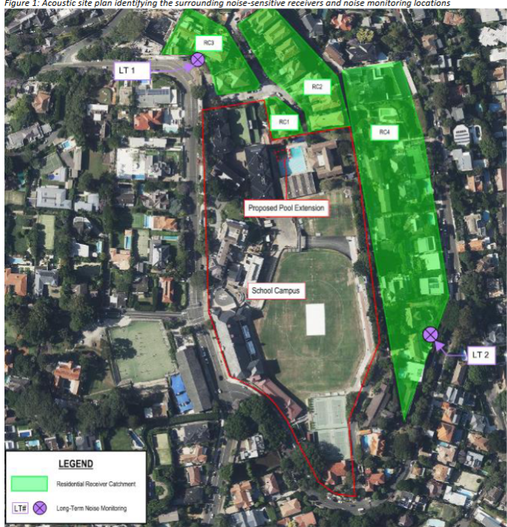

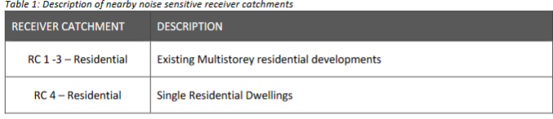

Long Term Noise Monitoring

Long term noise monitoring was undertaken at locations shown in Figure 1 above, to measure the background and ambient noise that is representative of the surrounding noise sensitive receivers. Background noise levels and subsequent Rating Background Noise Level (RBL) have been established in accordance with the Noise Policy for Industry 2017.

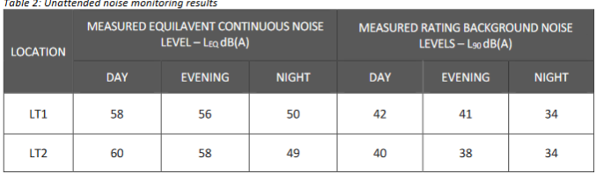

Project Specific Noise Criteria

There are no quantitative acoustic requirements specified within Council’s DCP and LEP in relation to noise emission levels for the project site. In the absence of this, the project noise emission criteria has been established using the NPfI.

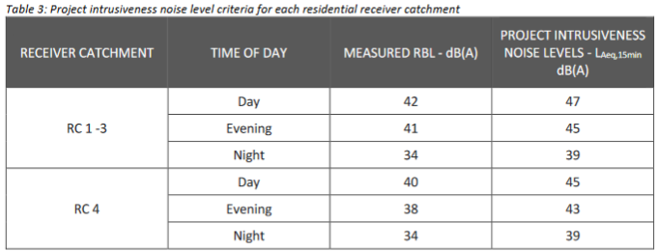

Noise Emission Assessment

- Operational Noise – Outdoor Swimming Pool (Student Numbers & Spectators)

Noise modelling software Sound PLAN v9.0 was used to assess noise emissions from the outdoor swimming pool at the nearest noise sensitive receivers. An allowance of up to 50 students at any given time using the pool has been modelled. In addition, 100 spectators seated in the spectator’s area cheering / shouting has been used for the assessment. Sound power levels used in
the model are presented below in Table 6.

The student numbers are also confirmed in the JMT Consulting Transport Impact Assessment 20 August 2024 - the existing outdoor pool for training for both swimming and water polo. It is also used on Saturdays for inter-school water polo games with typically 50 to 100 people currently attending matches.

It should be noted that the first submitted Acoustic Report: prepared by E-LAB Consulting – Project No. P01282 – Revision 001 – 16 August 2024 incorrectly stated the group of student numbers, where an allowance of up to 30 students at any given time using the pool was modelled. In addition, 15 spectators was modelled to be seated in the spectator’s area cheering / shouting has been used for the assessment.

The effective sound power levels for groups of students and spectators are predicted below.

Predicted Noise Emissions

The predicted noise emissions for the proposed expansion of the pool meets compliance to the Project Specific Amenity Criterion at all receivers. Refer to Table 7 below. The predicted noise emissions with the existing pool to the proposed extension does change the noise levels at the receiver catchments with only marginal increase of 1dB noted at receiver catchment 2. For any increase in sound levels to be perceptible the relative change is typically required to be 3dB or more.

The existing boundary to the pool area to the receivers along Aston Gardens is an open slatted fence, which does not provide any acoustic screening. It is proposed to build a spectator’s area which would shield noise emissions from the use of outdoor pool.

- Mechanical Services – Pool Plant

At this stage of the proposed development, the design has not progressed enough for pool plant and equipment selections are yet to be made. During the design development stage of the project, mitigation measures will be considered when preparing the mechanical services, to ensure compliance with the external noise emissions criteria established in Section 4.1 of the Report.

- Construction Noise

At development application stage, the construction methodology is unknown. Upon further details of the construction methodology a detailed assessment can be carried out to assess compliance to the nominated criteria. The Construction Noise Criteria applicable is designed to the Interim Construction Noise Guideline (ICNG) by NSW DEC.

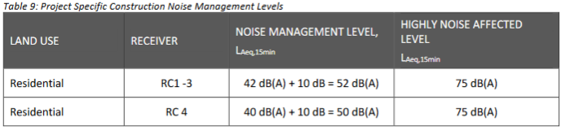

Noise and Vibration Management strategies are detailed in section 7 of the Report.

Environmental Health – Comment

Operational Noise – Outdoor Swimming Pool

Environmental Health is satisfied that operational noise from the outdoor swimming pool will not have an adverse noise impact upon nearby residential receivers.

Mechanical Services – Pool Plant

Prior to the issue of any Construction Certificate, an Acoustic Report, prepared by a suitably qualified acoustic consultant, shall assess the environmental noise impacts associated with the operation of all mechanical services – pool plant. The Acoustic Report shall have regard to the Project Intrusiveness Noise Level Criteria for each residential receiver catchment, as detailed in Table 3 of the Acoustic Report: prepared by E-LAB Consulting – Project No. P01282 – Revision 001 – 16 August 2024.

Construction Noise

Environmental Health recommends that the “Interim Construction Noise Guidelines” (published by the NSW Office of Environment and Heritage, 2009) be considered in the assessment of noise from construction activities, to advise on best practice approaches to minimise noise impacts. The ICNG provides noise management levels for construction noise at residential and other potentially sensitive receivers.

An appropriate assessment in compliance with DECCW’s Interim Construction Noise Guidelines June 2009 and DEC’s Assessing Vibration: A technical Guideline dated February 2006. Construction Noise Reports are usually appropriate at CC stage.

At the Construction Certificate stage, a Construction Noise Management Plan (CNMP) is to be prepared by a suitably qualified acoustic consultant. The construction noise will be assessed with consideration to DECCW Interim Construction Noise Guidelines (ICNG) (2009) to provide noise management levels for construction noise at residential and other potentially sensitive receivers. The management levels are to be calculated based on the adopted rating background level (RBL) at nearby locations.
The CNMP shall be a site specific plan developed to ensure that appropriate work practices are implemented during the demolition, excavation and construction to minimise noise and vibration impact. The CNMP shall include:

- Attended and unattended noise monitoring at locations indicative of noise sensitive receivers.
- Site description.
- Staging of construction.
- Establishment of project specific airborne noise construction goals based on monitored existing noise levels.
- Prediction of construction noise levels from proposed construction works.
- Recommendation of environmental noise control options/management practices.
- Complaints handling and community liaison procedures.

- RECOMMENDATION

Council’s Environmental Health Officer has determined that the proposal is satisfactory, subject to the following conditions:

- GENERAL CONDITIONS

A. |  | Approved Plans and Supporting Documents
A. |  | Those with the benefit of this consent must carry out all work and maintain the use and works in accordance with both the architectural plans to which is affixed a Council stamp “Approved” and supporting documents listed below unless modified by any following condition.  Where the plans relate to alterations or additions only those works shown in colour or highlighted are approved.  Notes:  - Warning to Principal Certifier – You must always insist on sighting the original Council stamped approved plans. You must not rely solely upon the plan reference numbers in this condition. Should the Applicant not be able to provide you with the original copy Council will provide you with access to its files so you may review our original copy of the approved plans.  - These plans and supporting documentation may be subject to conditions imposed under section 4.17(1)(g) of the Act modifying or amending the development.
  Reference | Description | Author | Date
  Document No. P01282 – Revision 003 | Acoustic Report | Engineering Lab NSW Pty Ltd | 03 March 2025
   | Plan of Management – Water Polo Pool | Urbis Ltd | 16 August 2024
A. |  | Condition Reason: To ensure all parties are aware of the approved plans and supporting documentation that applies to the development.

- BEFORE DEMOLITION WORK COMMENCES

- ON COMPLETION OF REMEDIATION WORK

- BEFORE ISSUE OF A CONSTRUCTION CERTIFICATE

D |  | Acoustics – Mechanical Services Pool Plant
D |  | Prior to the issue of any construction certificate, an Acoustic Report, prepared by a suitably qualified acoustic consultant, shall assess the cumulative environmental noise impacts associated with the operation of the mechanical services – pool plant & associated equipment.  The Acoustic Report shall have regard to the Project Intrusiveness Noise Level Criteria for each residential receiver catchment, as detailed in Table 3 of the Acoustic Report: prepared by E-LAB Consulting – Project No. P01282 – Revision 003 – 03 March 2025.  Where necessary, noise amelioration treatments will be incorporated in the mechanical services – pool plant design to ensure that cumulative noise levels comply with the noise emission criteria. Compliance noise testing is to be undertaken following the installation of all the mechanical services – pool plant.  Note 1: Compliance with the Night-time (RBL) noise emission criteria will ensure compliance at all other times.  Note 2: Note: ‘Suitably qualified acoustic consultant’ means a consultant who possesses Australian Acoustical Society membership or are employed by an Association of Australasian Acoustical Consultants (AAAC) member firm.
D |  | Condition Reason: To protect the acoustic amenity of the surrounding environment.

D |  | Acoustics – Demolition and Construction
D |  | At the Construction Certificate stage, a Construction Noise Management Plan (CNMP) is to be prepared by a suitably qualified acoustic consultant. The construction noise will be assessed with consideration to DECCW Interim Construction Noise Guidelines (ICNG) (2009) to provide noise management levels for construction noise at residential and other potentially sensitive receivers. The management levels are to be calculated based on the adopted rating background level (RBL) at nearby locations.  The CNMP shall be a site specific plan developed to ensure that appropriate work practices are implemented during the demolition, excavation and construction to minimise noise and vibration impact. The CNMP shall include:  - Attended and unattended noise monitoring at locations indicative of noise sensitive receivers.  - Site description.  - Staging of construction.  - Establishment of project specific airborne noise construction goals based on monitored existing noise levels.  - Prediction of construction noise levels from proposed construction works.  - Recommendation of environmental noise control options/management practices.  - Complaints handling and community liaison procedures.
D |  | Condition Reason: To protect the acoustic amenity of the surrounding environment.

D |  | Swimming and Spa Pools – Backwash
D |  | Before the issue of any construction certificate, the construction certificate plans and specifications required under clause 7 of the Development Certification and Fire Safety Regulation, must detail the connection of backwash to Sydney Waters sewer in compliance with clause 10.9 (Figure 10.2) of AS/NZS 3500.2.2.  Notes:  - The plans must show the location of Sydney Water’s sewer, the yard gully or any new connection to the sewer system including a detailed cross section of the connection complying with clause 10.9 (Figure 10.2) of AS/NZS 3500.2.2.  - The discharge of backwash water to any stormwater system is water pollution and an offence under the Protection of the Environment Operations Act 1997. The connection of any backwash pipe to any stormwater system is an offence under the Protection of the Environment Operations Act 1997.
D |  | Condition Reason: To ensure swimming and spa pool backwash is connected to Sydney Waters sewer.

D |  | Acoustic Certification of Mechanical Services Pool Plant
D |  | Prior to the issue of any construction certificate, the construction certificate plans and specifications, required under clause 7 of the Development Certification and Fire Safety Regulation, must be accompanied by a certificate from a professional acoustic engineer certifying that the cumulative noise level measured from mechanical services pool plant shall comply with Table 3 of the Acoustic Report: prepared by E-LAB Consulting – Project No. P01282 – Revision 003 – 03 March 2025.  Notes:  - Further information including lists of Acoustic Engineers can be obtained from:  - Australian Acoustical Society - professional society of noise-related professional www.acoustics.asn.au  Association of Australian Acoustical Consultant - professional society of noise related professionals www.aaac.org.au
D |  | Condition Reason: To ensure the development does not result in any unreasonable acoustic impacts.

- BEFORE BUILDING WORK COMMENCES

- DURING BUILDING WORK

F |  | Hours of Work –Amenity of the Neighbourhood
F |  | While site work is being carried out:  - No work must take place on any Sunday or public holiday.  - No work must take place before 7am or after 5pm any weekday.  - No work must take place before 7am or after 1pm any Saturday.  - The following work must not take place before 9am or after 4pm any weekday, or before 9am or after 1pm any Saturday or at any time on a Sunday or public holiday:  - piling,  - piering,  - rock or concrete cutting, boring or drilling,  - rock breaking,  - rock sawing,  - jack hammering, or  - machine excavation.  - No loading or unloading of material or equipment associated with the activities listed in part d) above must take place before 9am or after 4pm any weekday, or before 9am or after 1pm any Saturday or at any time on a Sunday or public holiday.  - No operation of any equipment associated with the activities listed in part d) above must take place before 9am or after 4pm any weekday, or before 9am or after 1pm any Saturday or at any time on a Sunday or public holiday.  - No rock excavation being cutting, boring, drilling, breaking, sawing , jack hammering or bulk excavation of rock, must occur without a 15 minute interval break within every hour.  Notes:  - The use of noise and vibration generating plant and equipment and vehicular traffic, including trucks in particular, significantly degrade the amenity of neighbourhoods and more onerous restrictions apply to these activities. This more invasive work generally occurs during the foundation and bulk excavation stages of development. If you are in doubt as to whether or not a particular activity is considered to be subject to the more onerous requirement (9am to 4pm weekdays and 9am to 1pm Saturdays) please consult with Council.  - Each and every breach of this condition by any person may be subject to a separate penalty infringement notice or prosecution.  - The delivery and removal of plant, equipment and machinery associated with wide loads subject to Transport for NSW and NSW Police restrictions on their movement outside the approved hours of work will be considered on a case by case basis.  - Compliance with these hours of work does not affect the rights of any person to seek a remedy to offensive noise as defined by the Protection of the Environment Operations Act 1997, the Protection of the Environment Operations (Noise Control) Regulation 2017.  - NSW EPA Noise Guide is available at www.epa.nsw.gov.au/noise/nglg.htm
F |  | Condition Reason: To mitigate the impact of work upon the amenity of the neighbourhood.

F |  | Dust Mitigation
F |  | While site work is being carried out, dust mitigation must be implemented in accordance with “Dust Control - Do it right on site” and the accompanying facts sheets published by the Southern Sydney Regional Organisation of Councils.  This generally requires:  - Dust screens to all hoardings and site fences.  - All stockpiles or loose materials to be covered when not being used.  - All equipment, where capable, being fitted with dust catchers.  - All loose materials being placed bags before placing into waste or skip bins.  - All waste and skip bins being kept covered when not being filled or emptied.  - The surface of excavation work being kept wet to minimise dust.  - Landscaping incorporating trees, dense shrubs and grass being implemented as soon as practically possible to minimise dust.  Notes:  - “Dust Control - Do it right on site” and the accompanying factsheets can be downloaded from Council’s website www.woollahra.nsw.gov.au  - Special precautions must be taken when removing asbestos or lead materials from development sites. Additional information can be obtained from www.safework.nsw.gov.au and www.epa.nsw.gov.au. Other specific conditions and advice may apply.  - Demolition and construction activities may affect local air quality and contribute to urban air pollution. The causes are dust, smoke and fumes coming from equipment or activities, and airborne chemicals when spraying for pest management. Precautions must be taken to prevent air pollution.
F |  | Condition Reason: To mitigate the impact of dust upon the amenity of the neighbourhood and prevent water pollution.

- BEFORE ISSUE OF AN OCCUPATION CERTIFICATE

- OCCUPATION AND ONGOING USE

H |  | Noise Control
H |  | During the occupation and ongoing use, the use of the premises must not give rise to the transmission of offensive noise to any place of different occupancy. Offensive noise is defined in the Protection of the Environment Operations Act 1997.  Notes:  - Council will generally enforce this condition in accordance with the Noise Guide for Local Government (www.epa.nsw.gov.au/your-environment/noise/regulating-noise/noise-guide-local-government) and the NSW Industrial Noise Policy (www.epa.nsw.gov.au/your-environment/noise/industrial-noise) published by the NSW Environment Protection Authority. Other State Government authorities also regulate the Protection of the Environment Operations Act 1997.  - Useful links:  - Community Justice Centres—free mediation service provided by the NSW Government www.cjc.nsw.gov.au.  - NSW Environment Protection Authority— see “noise” section www.environment.nsw.gov.au/noise.  - NSW Government legislation- access to all NSW legislation, including the Protection of the Environment Operations Act 1997 and the Protection of the Environment Noise Control Regulation 2017 is available at www.legislation.nsw.gov.au.  - Australian Acoustical Society—professional society of noise related professionals www.acoustics.asn.au.  - Association of Australian Acoustical Consultants—professional society of noise related professionals www.aaac.org.au.  - Liquor and Gaming NSW—www.liquorandgaming.nsw.gov.au.
H |  | Condition Reason: To protect the amenity of the neighbourhood.

H | H 2. 2. | Approved Hours – Use of the Outdoor Swimming Pool
H | H 2. 2. | - The outdoor swimming pool is to be used only during the daytime hours of 7am to 6pm, Monday to Saturdays, for swimming and water polo training and games.
H | H 2. 2. | Condition Reason: To protect the amenity of the neighbourhood.

Louie Salvatore 06 March 2025
A/Team Leader Building & Compliance Completion Date

